From vlan 20 pc to web server,
As expected public ip only able to ping not private of web server from inside also because we have done NAT hairpinning.
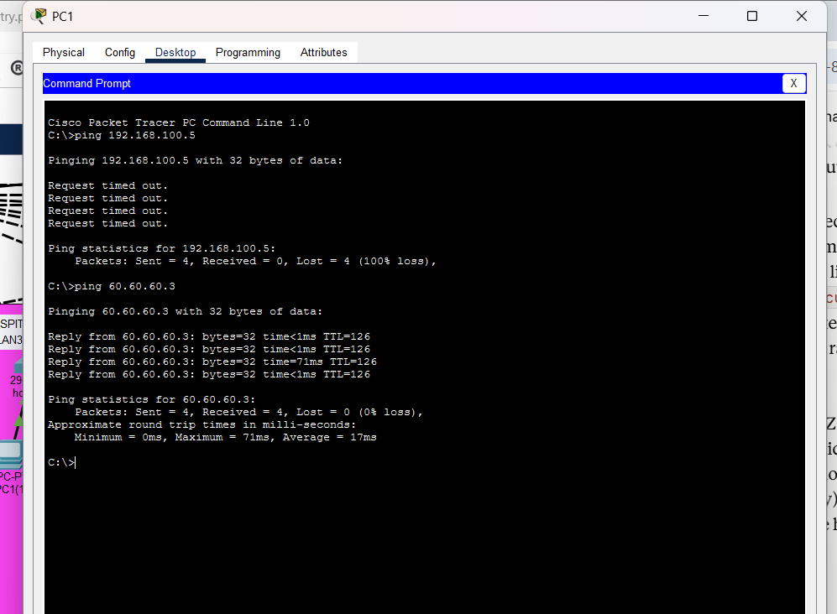
Same for mail server from inside network ,
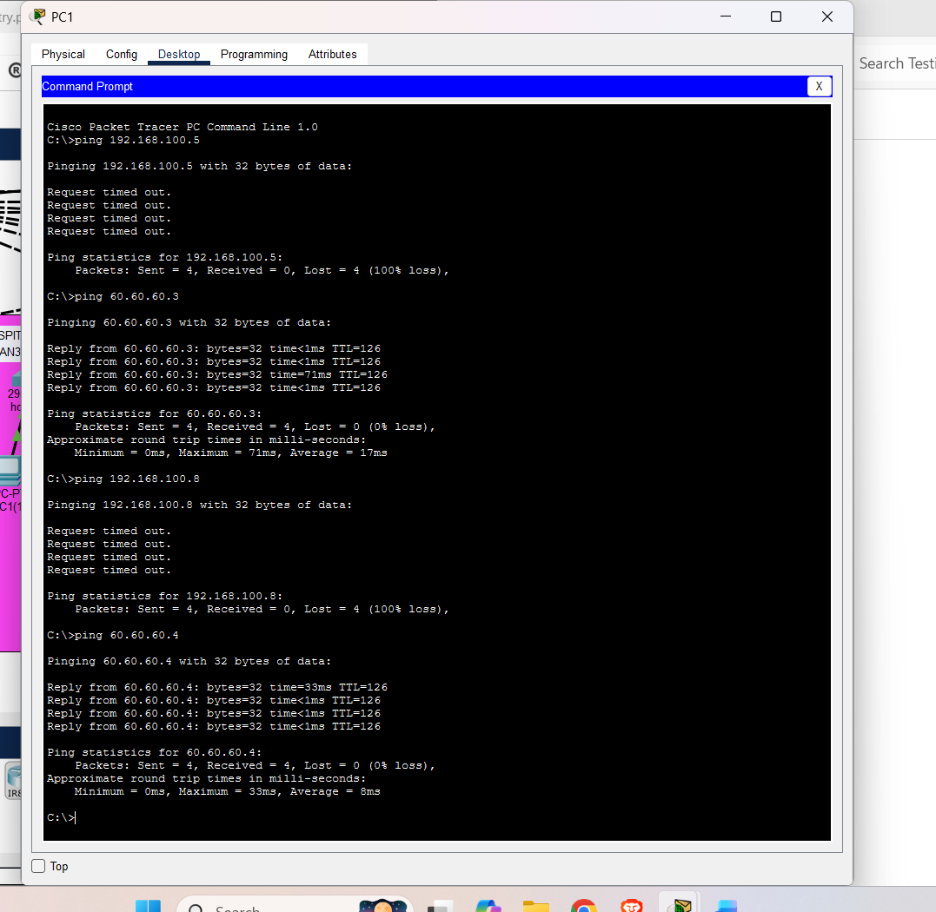
Lets try to ping from vlan 20 pc to vlan 30 pc
pc of vlan 30 ip check first,
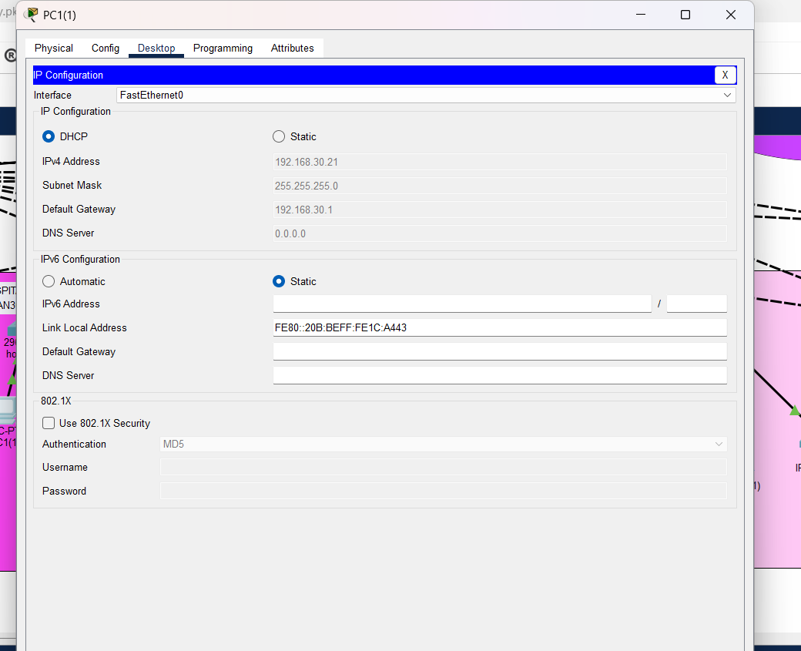
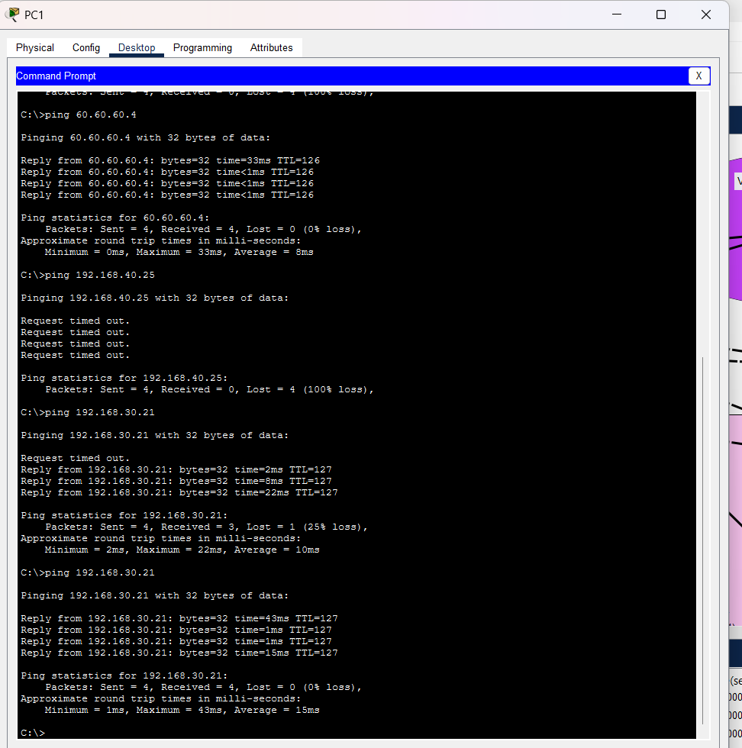
First packet might fail to ping ,
after you manually ping from vlan 20 pc to mls0 vlan 30 pc to mls0 than vlan 20 pc to vlan 30 pc it will be fixed, its just packet tracer working .
Vlan 40 and 50 are blocked for pinging 20 and 30 deny and also vlan 40, 50 can reach internet except internal network. Also have given permit to access dmzweb service.

